**Giuseppe Florio**

**Milan Sightseeing and Discover**

**Between past and present.**

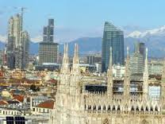

I dedicate this guide to

Solitary travelers

Edizione Pippo

Index.

This time the index is in the head so as to allow an immediate search before you start your walk, enjoy your visit.

Introduction page 3

Area Duomo page 5

Area Scala page 7

Piazza Cordusio page 9

Area Cairoli page 12

Area San Babila page 15

Zona Brera page 17

Navigli page 19

Garibaldi page 21

Area Magenta page 23

Venice Area page 26

Zone 5 Days page 30

Area Gae Aulenti page 32

San Siro page 33

Milan Maps page 34

Map of Milan Map of Transport Network on page 38

* have been some news from art Wikipidia

introduction

Milan to see in those historic places known and publicized, which basically are few compared to Rome or Venice, Florence, Naples, and to discover in all of those, and there are many, considered minor, but for true fans or experts are many.

I have organized this paper in areas with little useful information or to help generate curiosity.

Not being an expert, but a simple citizen, you will not find that information of the artistic monuments that can be found on the website of the municipality, prepared by De Agostino and you can download a beautiful City Guide very rich.

I added my personal experience in Milan, where I live since 1968, and as curious wandered without goals and without a map. Sometimes I lost myself because being circular, like a spider web, just missing a corner and you find yourself far away.

Follow this simple guide, but first studied the city; maps at the bottom.

Milan has three ring roads, which have followed the development of the city according to the story: that of the canals, was a circular channel along the medieval walls; that the Spanish walls, made ​​by the Spanish domination that were also high and we could walk over, (were few remains of Porta Romana); the outside of the 60s. Today, there are others that are not perfectly closed that have followed the growth of Milan in the last 40 years, then the ring of highways.

Referring to the central one are the names of the ports, which are then also "districts: Porta Vittoria, Porta Monforte, Porta Nuova, Porta Volta, Porta Tenaglia, Porta Magenta, Porta Ticinese, Porta Ludovica, Porta Vigentina.

Even along the ring of canals were the doors, Eastern Gate, from where it passes Renzo Betrothed, but they are lost in memories and in place names.

I try to do it as hypertext, in order to make it easier walking and using a tablet or smart.

On [this site](http://www.turismo.milano.it/) you will find everything in detail:

A valuable guide is on Page 36 in the map Art where you can direct you to the areas chosen to be discovered.

If you want to see footage of the interior of the churches and monuments, click on [this site](http://www.milanodavedere.it/category/rubriche/filma-mi/):

The Help is told in the first person as if I were your Cicero.

Good discovery, pippo

Zone ** Duomo (MM1).

The Cathedral is the center of Milan, not only geographically, perhaps today more for the great development in the North, but the religious and civic life. La Madonnina is the symbol of the people of all countries who live in Milan.

In Roman times it was the northern part of the city that was developed to the south the current Porta Romana, in fact the remains of the imperial city in the time of Constantine are spread to the south and west, Corso Magenta.

• Cathedral, still under construction, with its pinnacles that make it unique, in fact it says "the building of the cathedral" to mean that never ends. The visit is obvious, this is a must see.

• [Museo del Duomo](http://museo.duomomilano.it/) (new)

• Royal Palace: Royal House; Trade (annual). Former ducal palace fourteenth century, it was rebuilt in its present form by Piermarini (1778). It is among the most important exhibition venues in Milan. In 1951, Pablo Picasso chose the palace as the setting for his "Guernica", as an emblem of the havoc of war; not surprisingly, given that in 1943 the building was heavily bombed and lost all the decorations of the rooms inside.

• [Museo del Novecento](http://www.museodelnovecento.org/) (New) The Museo del Novecento in Milan is prepared a gallery exhibition of works of art of the twentieth century, housed in the Palazzo dell'Arengario and the adjacent Palazzo Reale in Milan.

• [Galleria Vittorio Emanuele](https://www.comune.milano.it/portale/wps/portal/CDM?WCM_GLOBAL_CONTEXT=/wps/wcm/connect/contentlibrary/Elenco+Siti+tematici/). The Galleria Vittorio Emanuele II in Milan is a covered passage that connects Piazza della Scala and the Duomo square with each other and with two roads through two short arms perpendicular to the main axis.

• [Church of San Satiro Bramante](http://arengario.net/momenti/momenti34.html) (Duomo corner Via Torino). The illusion is perfect. You enter in the Church of Santa Maria presso San Satiro in Milan (it is a complicated name) and it seems that, behind the altar, there is a large space ... find out.

I was bound to Cardinal Martini and I was in Piazza on the day of the funeral, I wrote a poem in Piazza del Duomo:

In front of the Duomo in Milan

In the queue for the Cardinal.

Prayer is present

The people are silent

In an atmosphere

Everyday

As if Martini

Were among us.

La Madonnina is watching us

And in his heart

Rejoices, his Milan

It is in prayer

For his Cardinal.

Symbol for all

The people who fill

Piazza del Duomo in Milan.

Piazza Scala **

• Special Exhibition on Leonardo (until late in the evening) at the end of tunnel angle Piazza Scala.

• Teatro alla Scala, visit the Museum and Theater (show tickets difficult), interesting visit to the museum and the hall.

• [Galleries of Italy](http://www.gallerieditalia.com/it/palazzi/piazza-scala) (the former seat BCI), Pinacoteca '800 and' 900 Lombardo, two entire buildings in Via Manzoni (new) Le Gallerie di Piazza Scala, housed in a prestigious building complex located in the heart of Milan, offering approximately 400 works of art of the century, accompanying the visitor in an exhibition spanning two centuries of Italian art.

The museum section from Canova to Boccioni exhibited 197 works of the nineteenth century, from Neoclassicism to the dawn of Futurism, from the collections of the Cariplo Foundation and Intesa Sanpaolo.

• Palazzo Marino (City Hall). The Town Hall since 1860, the palace was started in 1558 by the collector Thomas Marino. The facade towards La Scala in 1889, was born here the Nun of Monza cited by Manzoni's "The Betrothed." To discover.

• Church of San Fedele (paintings major). The church, erected in 1569 by the architect Pellegrino Tibaldi, is considered one of the most emblematic buildings of the Counter-Reformation. Commissioned by Cardinal Borromeo, the church was originally dedicated to San Fedele, proto-martyr of the diocese of Como, and destined to the Jesuits.

• [Museo Casa Manzoni](http://www.casadelmanzoni.it/), Piazza Belgaum

• Palazzo Belgaum, Opera neoclassical 1772-81 Piermarini, is modeled on the Palace of Caserta by Luigi Vanvitelli. It is considered one of the architectural treasures of the city.

• House of "Omenoni" for the big men of stone on the facade. Eight statues of men ("Omenoni") adorn the facade of the residence of the sixteenth-century sculptor Charles V, Leone Leoni. To discover.

• [Pinacoteca Ambrosiana](http://www.ambrosiana.eu/jsp/index.jsp) (near) Atlantic Code of Leonardo and famous paintings (Raphael)

Piazza Cordusio MM1 **

This is the City of Milan, with the headquarters of major national banks and foreign, by the Bank of Italy, the headquarters Unicredit and San Paolo.

From Piazza del Duomo, Via Mercanti.

• [Merchants Square](http://www.minube.it/posto-preferito/la-piazza-dei-mercanti-di-milano-a31851.) is a square in Milan created as a center of town life in medieval times, then turned into a street merchants. To piazza Mercanti means, in everyday language, the square circumscribed by the Palazzo della Ragione, the House of Panigarola and the Loggia of Osii. It was created from the middle of the thirteenth century with a rectangular plan, originally wider current. We opened six districts accesses referring to many citizens. The neighboring streets were named after the various activities carried out: Armorari, Uptown, Cappellari, Goldsmiths, Speronari, Fustagnari.

• The [Palace of Giureconsulti](http://www.palazzogiureconsulti.it/Palazzo_giureconsulti/La_Storia.kl) is one of the fundamental elements of the Piazza dei Mercanti, topographical center of Milan and the medieval heart of economic and social activities of those times. The construction of the Piazza dei Mercanti was decided in 1228, when the General Council of the Commune decreed the establishment of a new Broletto, trade center and administrative offices.

• Via Dante, the pedestrian shopping area

• Piazza della Borsa, or Piazza Affari. Italian Stock Exchange is a company that deals with the organization, management and operation of the Milan Stock Exchange (ie the Italian financial market) in order to promote the development and maximization of liquidity, transparency, competitiveness and efficiency. The origins date back to 1808, when Eugene de Beauharnais founded the "Chamber of Commerce of Milan

• Finger provocateur in Piazza Affari. Maurizio Cattelan (section Influence in mass culture). Art, L.O.V.E. Cattelan. The Finger of Cattelan remains after so much controversy.

• Registered Piccolo Teatro Europeo (three auditoriums). Via Rovello 2 Italian first permanent theater, the Piccolo Teatro in Milan (Teatro d'Europa by ministerial decree in 1991) was founded after the war by Paolo Grassi, Giorgio Strehler, Mario Apollonio, Virgilio Tosi and Nina Vinchi. The theater currently consists of three halls: the Hall Grassi (historic home of via Rovello), the Studio Theatre Spalato (experimental space that also houses the school of theater), the Teatro Strehler (headquarters, opened in 1998). After the death of Strehler, the direction was given to Sergio Escobar. Artistic director is the director Luca Ronconi.

• Registered EXPO 2015 Via Rovello 2 Expo Milano 2015 is a Universal with absolutely new and innovative. Not only an exhibition, but also a participatory process that aims to actively involve many actors around a crucial theme: Feeding the Planet, Energy for Life. A unique event that embodies a new concept of Expo theme, sustainable, technological and focused on the visitor. From 1 May to 31 October 2015, 184 days of event, more than 130 participants, an Exhibition Website developed on an area of ​​one million square meters to accommodate the more than 20 million visitors expected.

<http://www.expo2015.org/it> .

** Largo Cairoli (Expo Gate) MM1

Route from the Duomo to Castello, one kilometer walk

• [Castello Sforzesco](http://www.milanocastello.it/) (pedestrian area): Civic Museums with collections. The Castello Sforzesco, one of the most important monuments of Milan, had, in the course of its history, the long story of the building, brutal demolitions, reconstructions, restorations and embellishments, becoming a symbol of historical moments, happy and dramatic of the city. Contains paintings, armor, Egyptian section: frescoes by Leonardo.

• [Sempione Park](http://www.visitamilano.it/turismo/natura_e_sapori/?id=32448&evento=1&idbonsainode=42&urlp=Milano_-_Parco_Sempione_32448) (the largest of Milan). Sempione Park is a green area of the city of Milan. Built in the late nineteenth century on the already occupied by the parade ground, occupies an area of ​​386 000 m², fully fenced with video surveillance. The name comes from Corso Sempione, the monumental axis road built during the Napoleonic era on the route of the historic route of Herts, with the new port Sempione heir to the ancient port Jupiter.

• Park Tower in iron (110 meters Bar). Within the Parco Sempione, the Tower is a slender metal frame 108.6 meters high. Lictor called, is built on the occasion of the fifth Triennial Exhibition of Decorative Arts by architect Gio Ponti and inaugurated in 1933.

• [Arco della Pace](http://www.milanodabere.it/milano/monumenti/arco_della_pace.html) (Napoleonic period). At the center of Piazza Sempione there is the Arch of Peace, one of the most interesting examples of neoclassical architecture in the city. Its construction was started in 1807 by Luigi Cagnola to celebrate Napoleon's victories and temporarily stopped after the defeat at Waterloo. Opened in 1838, it is built in Baveno granite and marble tiles of Creole d'Ossola. On top of the monument stands a group of bronze statues depicting the sestiga of Peace accompanied by four wins on horseback, while the front shows the personifications of the rivers Po, Ticino, Adda and Tagliamento.

• Outdoor sculptures (including De Chirico). They are distributed in the Park and are turning to discover among the trees and lakes. There is also an old bridge of canals.

• [Triennale](http://www.triennale.it/it/) Design Museum and temporary exhibitions. La Triennale di Milano is hosted inside the Palace of Art, is a cultural institution that produces international exhibitions, conferences and events for art, design, art, design, architecture, fashion, cinema, communication and society.

It organizes exhibitions of great visibility and attention as those dedicated to contemporary art, architects and designers of national and international reputation, to the great designers who have changed the taste and style, to social issues. Since 2007 it houses the Triennale Design Museum, a museum that changes, attentive to the history and design of the entire system (firms, industrial districts, territories, research, publishing and training). Since 2011, hosts the Art Theatre, the most significant of the Milan panorama, new point of reference for cultural projects and performing arts.

Zone ** San Babila MM2

From the Cathedral all pedestrian.

• Corso Vittorio Emanuele, arcades, shopping area with international shops, bars with heated gazebo, etc..

• Rinascente department store with seven floors with a bar and food on top.

• Excelsior, department store like Harrods, foods and restaurant in the basement.

• [Church of San Carlo](http://www.sancarloalcorso.it/scc/), circular with relics of the saint. The Church of San Carlo al Corso is a Catholic place of worship in the center of Milan, located in the square, along the Corso Vittorio Emanuele. Built to replace the medieval church of Santa Maria dei Servi, Milan headquarters of the Servite, the current building is a fine example of similarities with the church of San Francesco da Paola neoclassical style, inspired by the Pantheon in Rome, Naples, with colonnade of the Piazza del Plebiscito in Naples.

• Piazza San Babila, especially square with arcades and shops

• The provost of the collegiate [Basilica](http://www.arte.it/guida-arte/milano/da-vedere/chiesa/chiesa-di-san-babila-1506) San Babila, known simply as San Babila, a Catholic place of worship is located in the square in Milan, at the confluence of the Corso Vittorio Emanuele II, over Europe, Corso Monforte and Corso Venezia.

• Brian & Berry, 12-story department store like Selfridges, foods and 4 restaurants run by EATALY.

• Fashion District, Monte Napoleone, Via della Spiga, Via cross.

• [Museum of Milan](http://www.costumemodaimmagine.mi.it/) in Via Sant 'Andrea. Two distinct pathways characterize the exhibition halls of the eighteenth century Palazzo Morando Bolognini Attendolo Via Sant'Andrea, 6.

Zone ** Brera.

From Piazza della Scala

• Via Verdi, Saint Joseph Church

• Ancient seat Cariplo, monumental building

• Via Brera, antique shops alla milanese "reserved"

• Palazzo Citterio, in Restorative Art Gallery for EXPO. Palazzo Citterio was acquired by the state in 1972 and since then he talks about his recovery and the project "Grande Brera" that it intends to be the venue of the permanent collections of the twentieth century the Pinacoteca di Brera, which events and temporary exhibitions.

• [Cusani Palace](http://www.amicidipalazzocusani.it/), the ancient palace. The family Cusani had acquired in the course of the seventeenth century a property at the Church of St. Eusebius, now disappeared: there Cusani Agostino (1592-1640), the feudal lord and then the Marquis of Chigwell would erect a building during the first decades of the seventeenth century

• [Pinacoteca di Brera](http://www.brera.beniculturali.it/), with a statue of Bonaparte, to visit one of the two state. The Pinacoteca di Brera is a national gallery of art, ancient and modern, located in a historic building in Milan. The museum houses one of the most famous collections of painting in Italy, specializing in painting Veneto and Lombardy, with important pieces of other schools. In addition, thanks to donations, proposes an exhibition that ranges from prehistory to contemporary art, with works by artists of the twentieth century.

• [Observatory of Brera](http://www.inaf.it/it/sedi/osservatorio-astronomico-di-brera) and botanical garden. The Astronomical Observatory of Brera, INAF, is a historic observatory consists in the second half of the eighteenth century in the palace of Brera in Milan. In the early twenties of the twentieth century the observation section was detached to Merate, in Brianza. The two sites share today the administration and direction, and sometimes the designation. Part of his fame is due to the observations of the Martian canals performed by Giovanni Virginio Schiaparelli in 1877.

• Via Fiori Chiari, area of shops, restaurants, stately as Monmatre.

• Church of San Marco. The church of San Marco is a Catholic place of worship in Milan, which is located in the homonymous square on the corner with Via Fatebenefratelli, and via San Marco, located in the San Marco district, on the border with Brera.

Zone ** canals.

From Piazza Duomo, the end of Via Torino. Corso di Porta Ticinese.

• Church of San Lorenzo with Byzantine mosaics, Roman columns with statue of Constantine; evening campfires from nightlife. The Basilica of San Lorenzo Maggiore is a Catholic place of worship located in Milan, inside the ring of canals, built in Roman times and rebuilt several times over the centuries. Located near the medieval port Ticino, is one of the oldest churches in Milan.

• Corso di Porta Ticinese with hippy shops

• [Diocesan Museum](http://www.museodiocesano.it/), with adjoining Cappella Portinari, Renaissance. The Diocesan Museum of Milan was founded in 2001 on the initiative of the Archdiocese of Milan with the aim to protect, promote and make known the artistic treasures of the diocese within the spiritual context that inspired them. A masterpiece for Milan.

• [Church of Sant'Eustorgio](http://www.santeustorgio.it/storia_della_basilica.html), one of the first basilicas with catacombs. The Basilica of Sant'Eustorgio is a Catholic place of worship, located in the square in Milan, near Porta Ticinese.

• [Navigli](http://www.navigli.milano.it/) area all closed two canals with one input and one output, with a marina, restaurants and pizzerias ice cream from all sides; now important place to see in the evening. Are a system of irrigation canals and waterways, with Milan center of gravity, which connected the lake Maggiore, Como and Ticino low opening to the streets of Milan and in Northwestern Europe Switzerland, Graubünden and North Eastern Europe and finally, one of the Po towards the sea. With regular regime of the waters of the canals is irrigated vast areas and made productive by connecting with the reclamation work started by the monks of the Abbeys south of the city as early as the tenth century. The construction of the entire system lasted from the twelfth to the nineteenth century. The ring of canals, or internal trench, was the "hinge" town that allowed the operation of the system as a whole.

• [Galleries of painters](http://www.circoloartenavigli.com/Default.aspx) and alley of the [washerwomen](http://www.turismo.milano.it/wps/portal/?WCM_GLOBAL_CONTEXT=it/SITur/HOME/miperte/numeriserviziutili/altriluoghi/loc3708), many restaurants in the old factories with music.

Garibaldi Area **

• From Piazza Cordusio, Via Broletto and then Via Ponte Vetero

• [Church of the Carmine](http://www.turismo.milano.it/wps/portal/?WCM_GLOBAL_CONTEXT=it/SITur/HOME/artecultura/architettura/loc600), interesting old church and restored. The church of Santa Maria del Carmine is a Catholic place of worship in the city of Milan, located in Piazza del Carmine, in the Brera district. It is the seat of the territorial parish of Santa Maria del Carmine Archdiocese of Milan, the parish English-speaking staff of St. Charles (English: St. Charles Parish) and the chaplaincy of the community of the faithful Filipinos in Milan

• Corso Garibaldi, ancient way of Milan, now closed to traffic and redeveloped with nice shops and Bar.

• [Church of San Simpliciano](http://www.turismo.milano.it/wps/portal/?WCM_GLOBAL_CONTEXT=it/SITur/HOME/artecultura/architettura/loc219), where he started the carroccio for the battle against Barbarossa. The Basilica of San Simpliciano is an important place of Catholic worship in Milan, which is located in the homonymous street, a side street of Corso Garibaldi. It is often the venue for concerts of Baroque music. On the site of the present church was built in the third century a pagan cemetery documented by the remains of marble discovered in the surrounding area. Although there is no historical evidence certain about this, it is argued that Ambrose was to start building the "Basilica Virginum", one of four churches strategically placed on the four main roads out of the city, which led to the subsequent urban planning.

• [Church of St. Mary the Crowned](http://www.turismo.milano.it/wps/portal/!ut/p/c0/04_SB8K8xLLM9MSSzPy8xBz9CP0os3hzS0O_QGcLEwMLFzcjA08LAz8TH2cnAwMDI_2CbEdFAF5vJvA!/?WCM_GLOBAL_CONTEXT=/it/situr/home/artecultura/architettura/loc4434), two churches in one for the Sforza. The church of St. Mary the Crowned is a Catholic place of worship in Milan, located at the intersection of Corso Garibaldi and Via Marsala. This church is a special case of "double church" similar to that of S. Cristoforo at Naviglio (also in Milan): Looking from the churchyard, the church on the left is the oldest, because it already existed in the communal age, was straight from the fathers hermits of St. Mark and was dedicated to St. Mary of Garegnano. Next to the church, at the beginning of the fifteenth century, a monastery was built by the Augustinian fathers, who restored the ancient church in the late Gothic style, typical of that century. Since the work was completed on the occasion of the coronation of Francesco Sforza, Duke of Milan (1451), they named the Santa Maria Crowned, dedicating it to the new lord of the city.

Area Magenta **

From Piazza Cordusio, Via Marvel and bottom of Corso Magenta.

Always been an area well, full of palaces and old houses, secluded inner gardens to discover. Prevailing development in the nineteenth century.

• [San Maurizio al Monastero](http://www.arte.it/guida-arte/milano/da-vedere/chiesa/chiesa-di-san-maurizio-al-monastero-maggiore-1502), a former Church of cloistered nuns, with frescoes by Luini, two bodies, according to the Organ '600 for concerts in the evening (little jewel of Touring). The church is a real gem. Century, its interior is completely painted, in good part by Bernardino Luini. San Maurizio al Monastero Maggiore is a church in Milan, once home to the largest nunnery in the city, belonging to the Benedictine order, placed at the corner of Via Luini and Corso Magenta, early Christian, rebuilt in the sixteenth century. It is decorated internally with a vast cycle of frescoes of the school of Leonardo, and is referred to as the "Sistine Chapel" of Milan or Lombardy

• [Archaeological Museum](http://www.arte.it/guida-arte/milano/da-vedere/museo/civico-museo-archeologico-1587) next door, with the remains of the Roman period and beyond, the tower of the Roman walls, interesting. The Civic Archaeological Museum of Milan is an archaeological museum, housed in the former convent of the Monastery of San Maurizio greater, where there are sections Greek, Etruscan, Roman, Barbarian and Gandhara. The prehistoric section and Egyptian is hosted at the Castello Sforzesco.

• [Palazzo Litta](http://www.milanofree.it/milano/monumenti/palazzo_litta.html), rich and aristocratic palace, the seat of the Superintendency of Monuments. Opera in 1648 by Francesco Maria Richini, has a beautiful rococo façade and a spectacular courtyard with portico. To discover. Litta Palace is a historic building situated in Corso Magenta in Milan. Although it is often referred to as one of the most important examples of Baroque architecture in Milan, Palazzo Litta is a subject of study with a bibliography extremely thin, which is not reflected in the high regard that is found in the words of the scholars who over the centuries have dealt its events. Often referred to only in passing in the itineraries of historical guides more or less recent, more rarely treated in a suitable space to its reputation, this building lacks a text that is in a position to clarify the many issues are still open regarding it.

• Shops rich and sober for the Milanese who flee the quadrangle.

• Bar Magenta, liberty and for Celentano famous in the film Ace.

• Behind the [Basilica of Sant'Ambrogio](http://www.milanotour.eu/it/cosa-vedere-milano/le-basiliche-le-chiese-di-milano/basilica-santambrogio.html) and Catholic University. The Basilica of Sant'Ambrogio, whose full name is Roman basilica minor collegiate abbey provost of St. Ambrose, is one of the oldest churches in Milan and is located in Piazza Sant'Ambrogio. It is today not only a monument to the early Christian period and the Middle Ages, but also a key point in the history of Milan and the Ambrosian church. It is traditionally considered the second most important church of the city of Milan.

• In addition to cross Santa Maria delle Grazie with Leonardo's Last Supper (visits limited to groups, you must book in advance).

• In front of the [Palazzo delle Stelline](http://www.stelline.it/it/homepage), Sixteenth, is a landmark in the cultural life and congress town. Once upon a time "Hospital of the beggars", became the main girls' orphanage in Milan. The term "star"; three bodies, to discover, renovated office with the European Community, the French Cultural Center, conference rooms, office Eni Foundation, tree and beautiful 3 star hotel. View of the Basilica. Behind a beautiful garden called: the gardens of Leonardo.

Zone ** Porta Venezia.

From Piazza San Babila, Corso Venezia.

After a lovely shops.

• [Palace of the Counts Serbelloni](http://www.fondazioneserbelloni.com/). Palazzo Serbelloni was one of the first palaces built on the course, which at the turn of the eighteenth and nineteenth century, radically changed appearance, to go from almost country road, to elegant course of the carriages. On site there was already a seventeenth-century building, and some medieval buildings: the facade is radically changed by Simone Cantoni, who designs the neoclassical portico that characterizes the facade, finished in 1793

• Home building of Invernizzi, in the back garden with flamingos and peacocks. Invernizzi Palace is a beautiful building inspired by the classicism that overlooks Corso Venezia Avenue promenade of beautiful ladies in a carriage during the '700 and 800. The reputation of the building, however, is entrusted to the rear [garden](http://www.visitamilano.it/turismo/percorsi_ed_itinerari/?id=47450&idsoggetto=47455&idbonsainode=0&urlp=Giardino_Invernizzi__47455), on Via dei Cappuccini, which is home to a large colony of pink flamingos, peacocks, ducks.

• Palazzo Liberty Sommaruga ASCOM headquarters, after public gardens. Castiglioni Palace is a palace of Milan, located in Corso Venezia. 47 Built by Giuseppe Sommaruga (1867-1917) in 1901-1904, is a bit '"manifesto" Art Nouveau in Milan. The building was built in three floors, with two sides, one on the main road and access to the garden, the more attached and detached from the main body constituting the stables and barn.

This building has a basement with rough ashlar which reproduces the natural forms of the rock; the other decorations are a recovery of the grout in eighteenth-century style.

• [Public Gardens Indro Montanelli](http://www.turismo.milano.it/wps/portal/?WCM_GLOBAL_CONTEXT=it/SITur/HOME/milanodintorni/parchigiardini/loc10). It is rich in palaces, museums and so on. Have been named to the journalist Indro Montanelli in 2002 was the first park in Milan expressly intended to recreation collective. For over two centuries were called "public gardens", "gardens of Porta Venezia" or simply "the gardens", and use yet taken root.

• Palazzo Dugnani.

• [Villa Reale](http://www.lombardiabeniculturali.it/architetture/schede/LMD80-00546/) salt of Napoleon. The Villa Reale in Milan (now Villa Comunale), formerly Villa Belgiojoso or Villa Belgiojoso Bonaparte, is a villa built between 1790 and 1796 by the architect Leopoldo Pollack, commissioned by Count Ludovico Belgiojoso Barbiano. The building turns its back, where there is the entrance to the Galleria d'Arte Moderna di Milano, Via Palestro looking out to the gardens so Indro Montanelli's Porta Venezia. The facade of the Villa is instead directed toward the English-style garden also designed by Leopoldo Pollack. The Villa Reale in Milan is one of the main monuments of neoclassicism in Milan. Among the works in the neoclassical Villa were those of Louis Buying and Antonio Canova.

• [PAC Pavilion](http://www.pacmilano.it/mostre/). Pavilion of Contemporary Art

• [Planetarium](http://www.astrofilimilano.org/circolo/planetario/planetario.php). The Planetarium of Milan is an educational museum building with a dome, within which a planetarium projects the image of the heavenly bodies and their movements in the sky. Located in the gardens of Porta Venezia in Milan, was inaugurated May 20, 1930 by architect Piero Portaluppi, who built on commission for the Swiss Pearson Education, Inc. who donated it to the city

• [Natural History Museum](http://www.assodidatticamuseale.it/ADM/), very nice. ll Museum of Natural History of Milan was founded in 1838 and is one of the most important natural history museums in Europe. In 2008 it was visited by 350 000 people

• Arco di Porta Venezia.

• Corso Buenos Aires, 2 km, full of shops, international and always open. Corso Buenos Aires is a major shopping street in Milan, with over 350 stores of various kinds of goods, a total daily turnover among the highest in the world and an average of one hundred thousand people every day. Growing at over 1600 meters, with north-south orientation, stands as one of the longest shopping strolls in Europe. Its shape recalls the American type, especially on Fifth Avenue in New York. The road stretches from port in Venice Piazza Oberdan, continue straight on Corso Venezia to Piazzale Loreto. The entire course Buenos Aires, recently upgraded with new paving of sidewalks (formerly in bitumen), is part of Zone 3 There lies the Puccini Theatre, current home of the theater company Teatro Elf

• Piazza Loreto. Piazzale Loreto is a square in Milan (located at the end of Corso Buenos Aires, in zone 2 on the border with zone 3) and the beginning of Viale Monza and Via Padova, is an important hub for transportation in the city, being placed along the outer ring. He is best known for being the scene of two events of the Second World War. In the massacre of Piazzale Loreto, August 10, 1944, the Legion soldiers were shot Autonomous Mobile Ettore Muti fifteen anti-fascist partisans on the sidewalk between Viale Andrea Doria and Corso Buenos Aires. He was also exposed Mussolini upside down (the current commemorative stele is slightly shifted to the center of Viale Andrea Doria).

Area Piazza 5 days.

From MM1 San Babila

• Take Route Durini, a street full of upscale shops and historic buildings and modern, the corner is Brian & Berry, 12-story department store Selfridges type of foods and 4 restaurants run by EATALY.

• Piazza Augusto

• Course door that leads to Piazza Vittoria 5 days.

• [Palazzo Sormani](http://www.visitamilano.it/turismo/musei_e_cultura/index.html?id=1180&idbonsainode=26), central municipal library. Palazzo Sormani is a historical building in the city of Milan, located in Corso di Porta Vittoria 6, now the headquarters of the Central Library of the city

• [Church of San Pietro in Gessate.](http://www.arte.it/guida-arte/milano/da-vedere/chiesa/chiesa-di-san-pietro-in-gessate-1522.) The church of San Pietro in Gessate is a Catholic place of worship in Milan. Located in Corso di Porta Vittoria, opposite the Palace of Justice, not far from Piazza Fontana, the church dates from the fifteenth century and is a fine example of architecture of the fifteenth century Lombardy.

the Conservatorio Giuseppe Verdi, with the [Church](http://www.arte.it/guida-arte/milano/da-vedere/chiesa/chiesa-di-santa-maria-della-passione-1510) of the same name, the two bodies of old, venue for many concerts. Music Conservatory "Giuseppe Verdi" in Milan. Serves as a backdrop to the Way of the Passion, located not far from San Pietro in Gessate and the Palace of Justice, and is one of the most beautiful monuments of the late Renaissance Milan.

• In front of the [Court](http://www.milanoguida.com/visite-guidate/altri-monumenti-milano/palazzo-di-giustizia-milano/). The Palace of Justice in Milan, home to the court, based on a Freguglia. It was built between 1932 and 1940 by Marcello Piacentini. For its construction, in the rationalist style monumental, were demolished church of San Filippo Blacks and the convent of the Slaves of Mary. The building was decorated internally with different mosaics, reliefs, frescoes and sculptures inspired by the Roman artistic tradition, they had to illustrate the story of Justice. Imposing Latin phrases on the principles of the Law dominate the main entrance on the main facade and two wings.

Square neighborhood Gae Aulenti

At the end of Corso Garibaldi arrives in Piazza XXV Aprile.

• EATALY Emerald, from their website: Each day from Eataly Milan Emerald you can buy, taste and learn about the high quality of products good, clean and fair.

• Corso Como, the top models of the nightlife with bars, restaurants and nightclubs, not to be missed is a courtyard in Corso Como 10 in a bar with a restaurant and the best of Made in Italy.

• After a short climb at the end of the modern Corso Como leads to the [Piazza Gae Aulenti](http://milano.mentelocale.it/53713-milano-piazza-gae-aulenti-po-berlino-sotto-madonnina-foto/), Rockefeller Center Unicredit in Milan with the tower over 200 meters high. The square is surrounded by skyscrapers, shops, a central pond with a fountain where you can walk. Leaving behind the square with a long path to walk you walk along all the skyscrapers to the one named Diamond because of its shape. A bar Feltrinelli bookshop can create a moment of pause.

Portello area and San Siro. (To be done by bus)

It starts from Piazza Cadorna and you wander the streets: MM stops Conciliation, Pagano Buonarroti, Fair and here the former area of the old Trade Fair, with the next three skyscrapers, (now soars the highest in Italy, 216 meters). Here is the hatch area, new buildings, skyscrapers, and a Central Park nearing completion.

From the door you go to San Siro, sports facilities and in the old Racecourse gallop, a horse 8 meters high. From Wikipedia: "The project has been going on between numerous difficulties and eventually the direction of the work was given to the sculptor Nina Akamu who finally carried through the enterprise. The first step has been to realize a horse of small size, about 3 meters in height. This was the first model to arrive at the giant sculpture in clay by almost 8 meters. It is the horse of clay that have been created where the casts were poured the molten bronze. "

The seven parts in which the horse was melted arrived in July 1999 in Milan, where they were welded together. After some discussion, the horse was placed in September 1999 at the entrance to San Siro racecourse.

[Stadio San Siro](http://www.sansiro.net/) Museum. The Stadio Giuseppe Meazza is a football stadium in Milan, and the most capacious of Italy, with a total of 81,277 seats (of which 80,018 distributed in the three rings), as well as one of the most famous and prestigious soccer facilities in the world, so much so that it has been dubbed the "Scala del Calcio". The facility hosts the home matches of AC Milan and Inter.

Until 1980 it was called San Siro Stadium, named after the neighborhood in which it stands. Primarily intended to football, since the seventies also hosts large concerts internationally; in 2009 he also hosted a meeting of the Italian national rugby committed against New Zealand, recording the highest turnout in Italy for a meeting of the governing

Like all the guides who respect I close with these maps:

Map of Milan Monumental page 35

Map of Milan Artistic page 36

Map of Milan Metro page 37

Transport Network Map on page 38

Plant Monumental Center in Milan with the border before the ring, the inner or the canals.

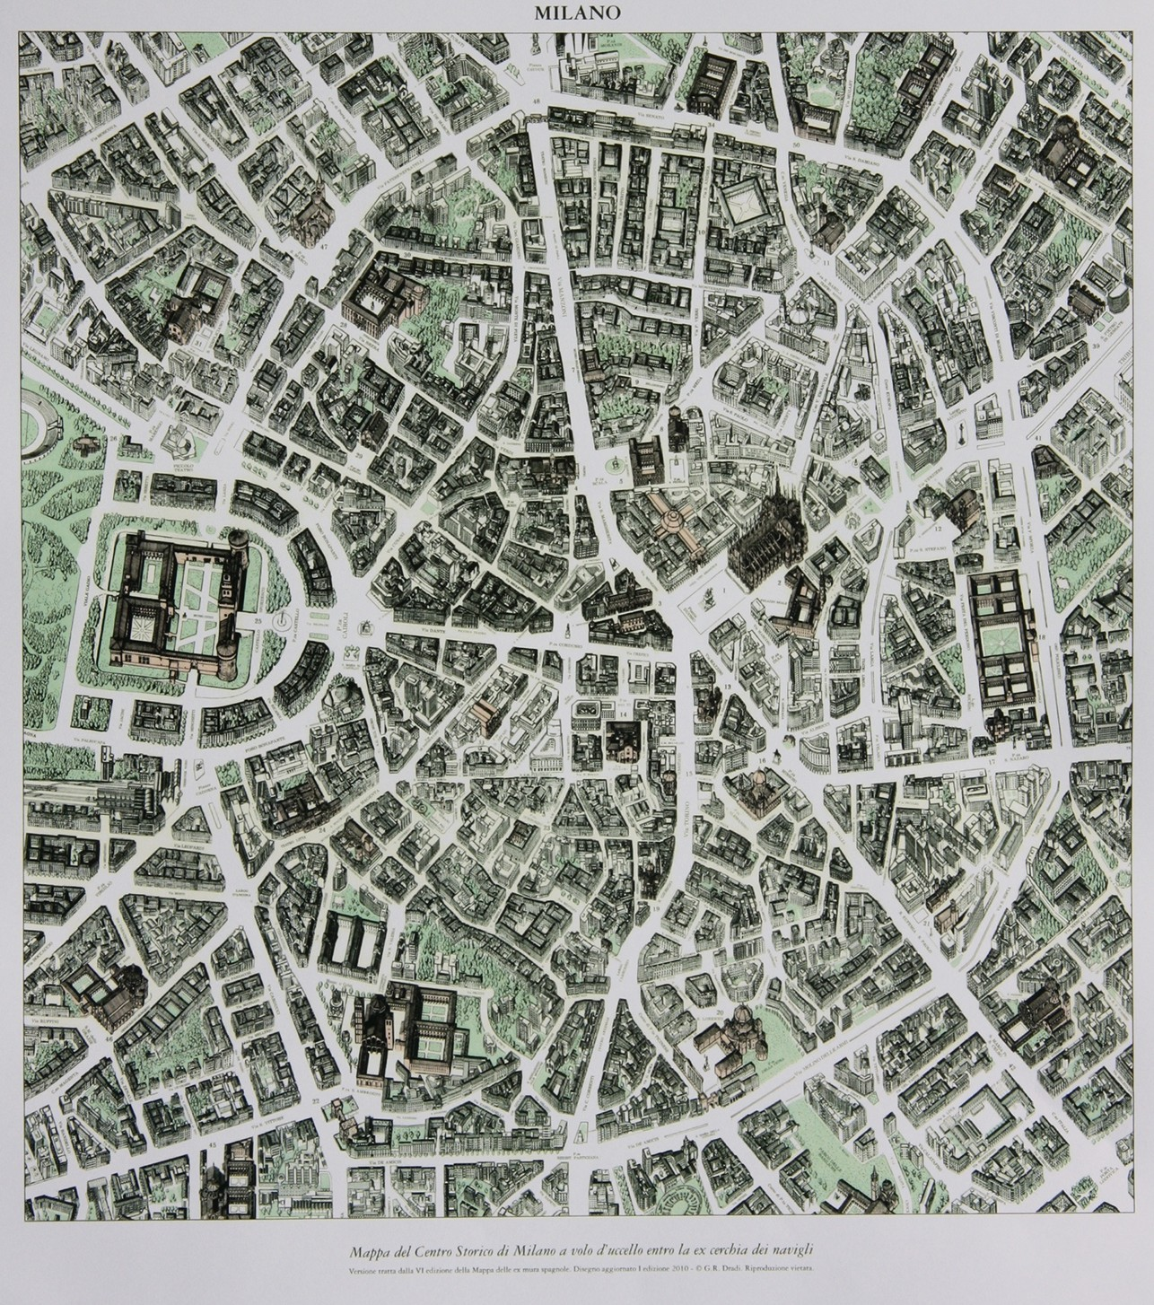

Plant Art Center in Milan border with the second ring road, the middle or the Spanish walls.

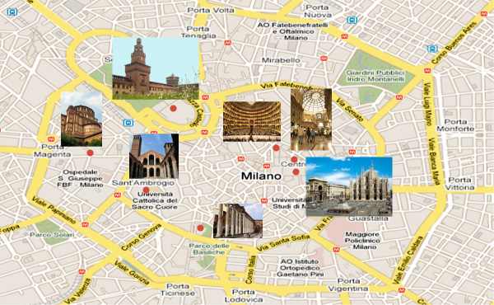

Starting from Piazza Duomo and following the various spokes (the doors) are the areas of the guide you choose which direction to take.

Plant global dell''area Milan metropolitan area with about 140 municipalities involved. At the terminus of the stops or terminals MM end Highways A1, A4, A7, or Tangenziali large car Parking.

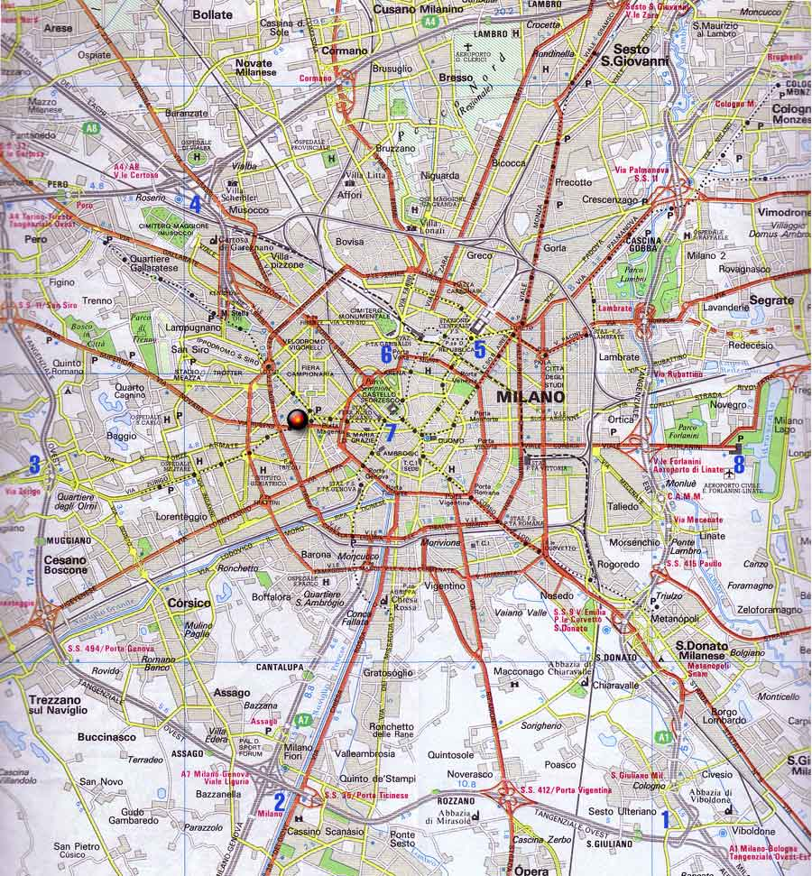

This is the plan of the network Milanese is full of 5 metro lines, that of the railway, which creates 12 suburban lines such as allowing you to go from Novara to Milan Pavia going under, the dense network of FNM.

